**WireFrames Description**

1. The login page

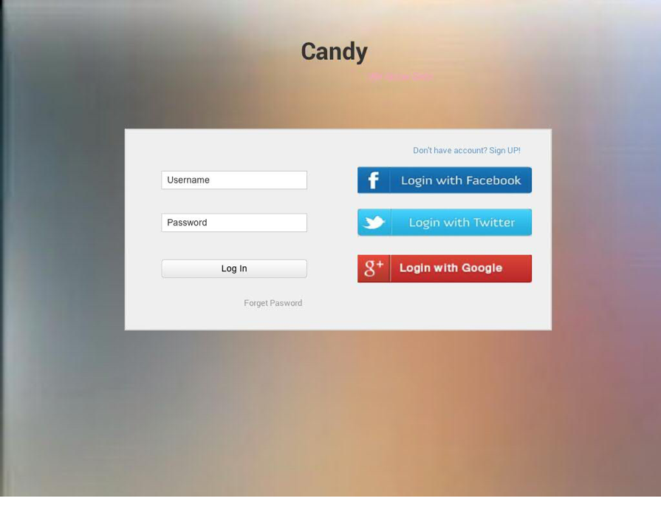

The login page allows the user to login with their username and password. They can also log in with their Facebook, Twitter or Google account. When their click on the “Sign Up”, they are navigated to the user register page. When they input the correct username and password and click on log in button, they will be navigated to the main page.

1. register page

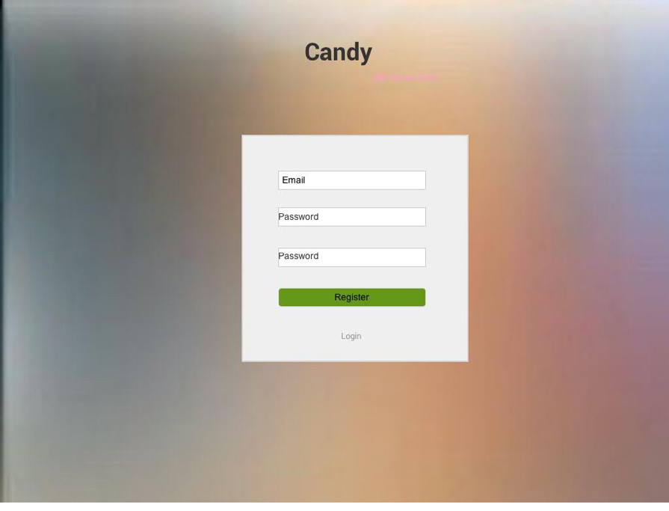

1. main page

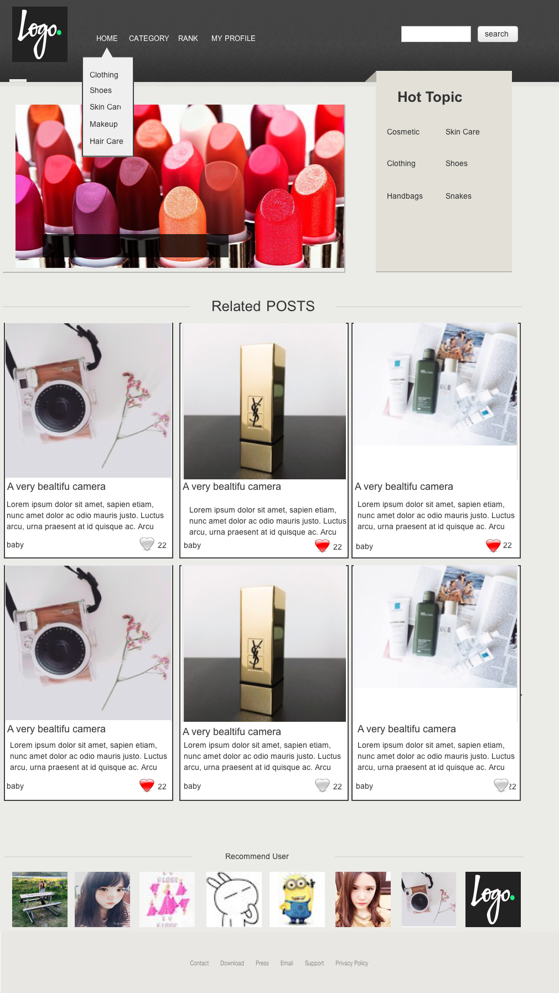

The navigation bar includes: Home, Category, Rank and My profile link. When user click on home link, they will be navigating to the main page. When they click on category, all the categories will be drop down and then allows user to choose the category. When they choose rank, they are directed to the rank page, which contains the ranking of particular items. When user click my profile link, they are navigated to their profile page.

And in main page, there are some recent posts, when user click on the posts’ picture, they will be navigated to the post detail page. And there are also recommend user, when user click on them, they will be navigated to the user’s profile page.

1. Post

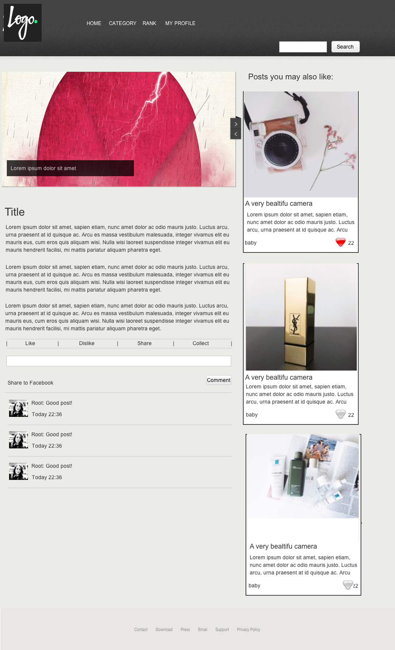

Post page just contains the post’ details and its comment. Users can make comment on post page. It also recommends some other posts that this user may like as well. User can also like, dislike this post. And can also share it or collect it to its collection.

1. User-self Profile page:

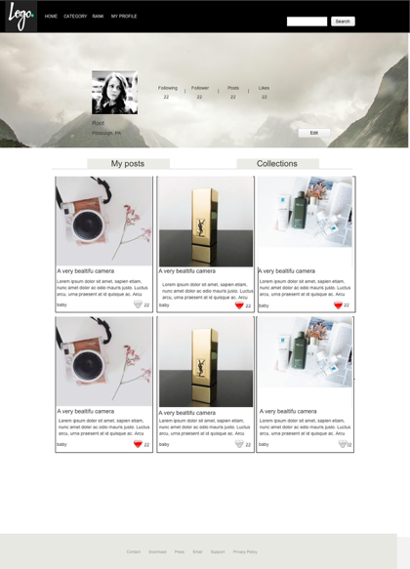

In this page, user can view his/her following, follower, posts. When they click on the edit button, they could edit their profile.

1. User-other Profile page:

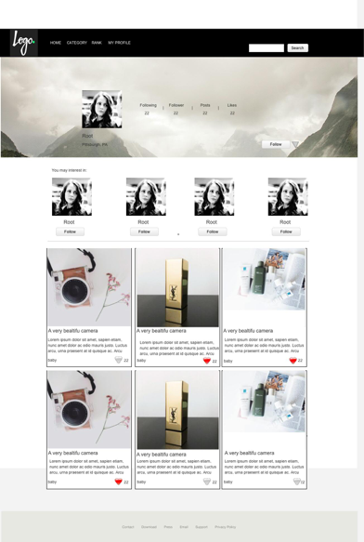

In this page, user view other user’s profile page.

In this page, user can view other users’ following, follower, posts. User can choose to follow/unfollow this user. There are also some recommendations of other users as well.

1. Change Profile Page:

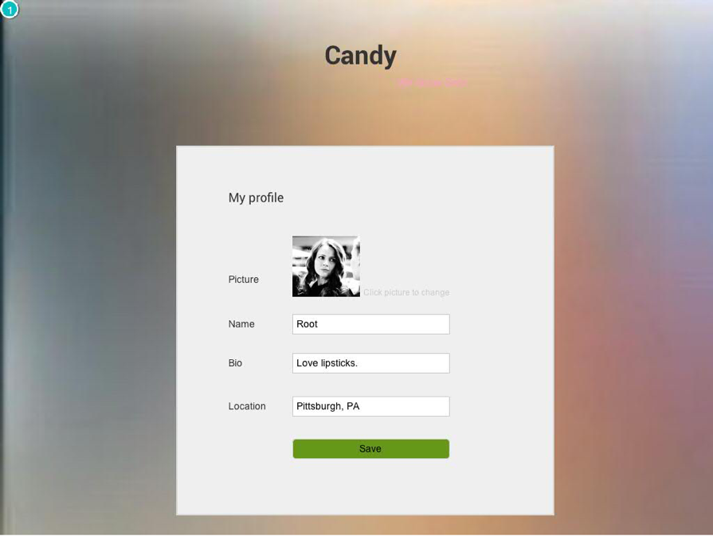

In this page, user can change their profile.

1. Upload Post:

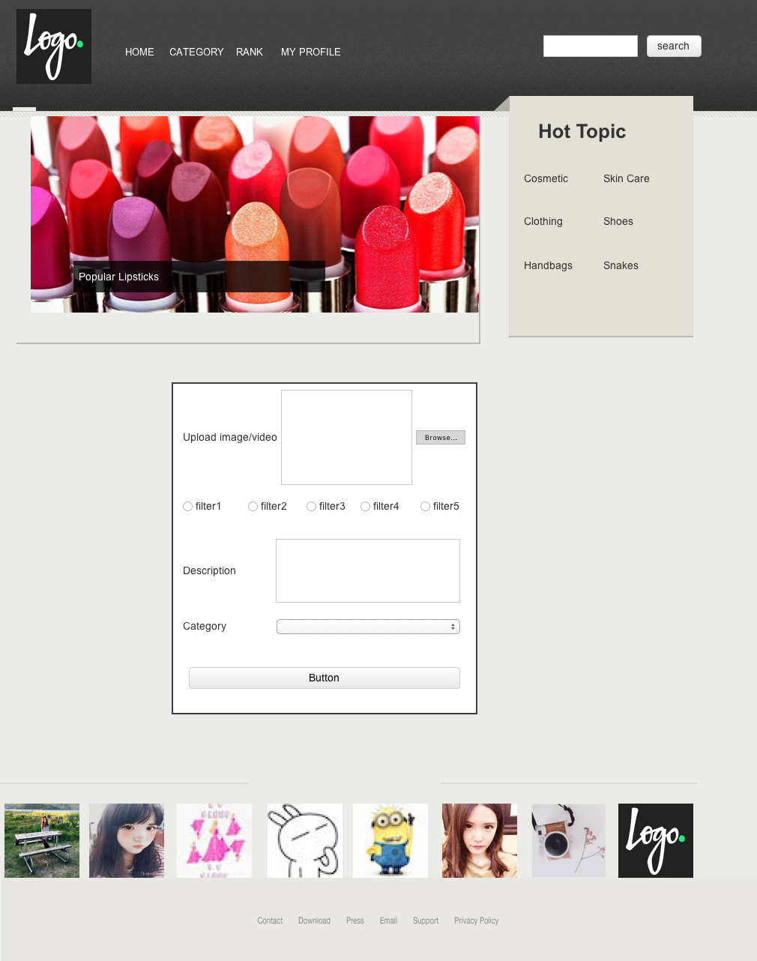

In this page, user can upload a post. A post must contain a post title, at least one picture, a short description (up to 300 characters), post category, postdate and post location.

1. Search Result Page:

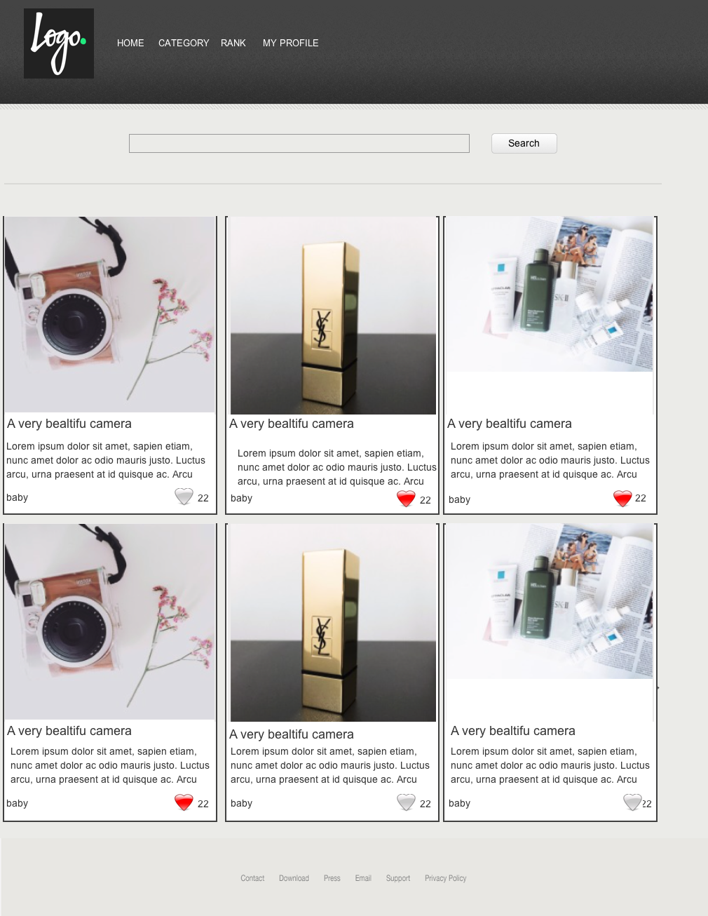

This page is the list of searched results.

1. Rank Page:

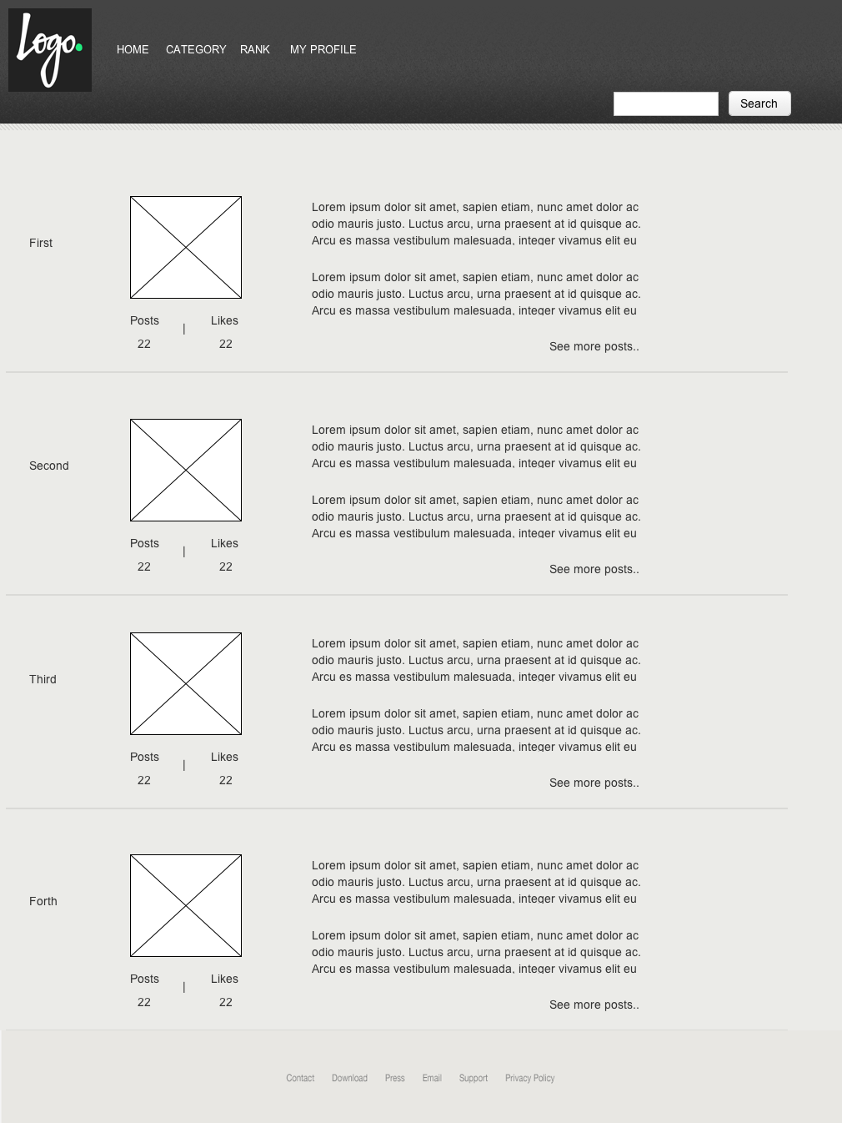

In this page, user can view the ranking result of items.

1. Following Page:

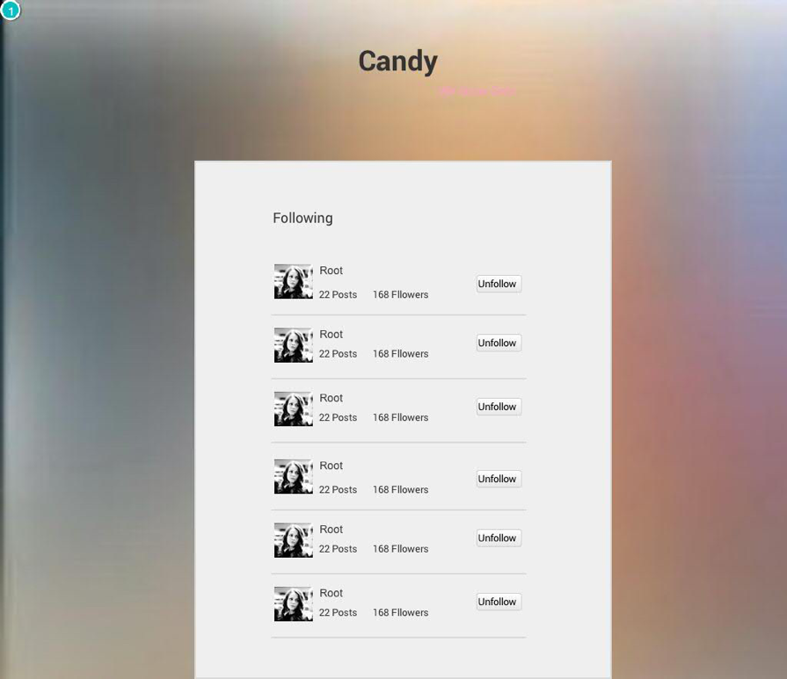

This page allows users to view his/her self’s following and other user’s following.

1. Follower Page:

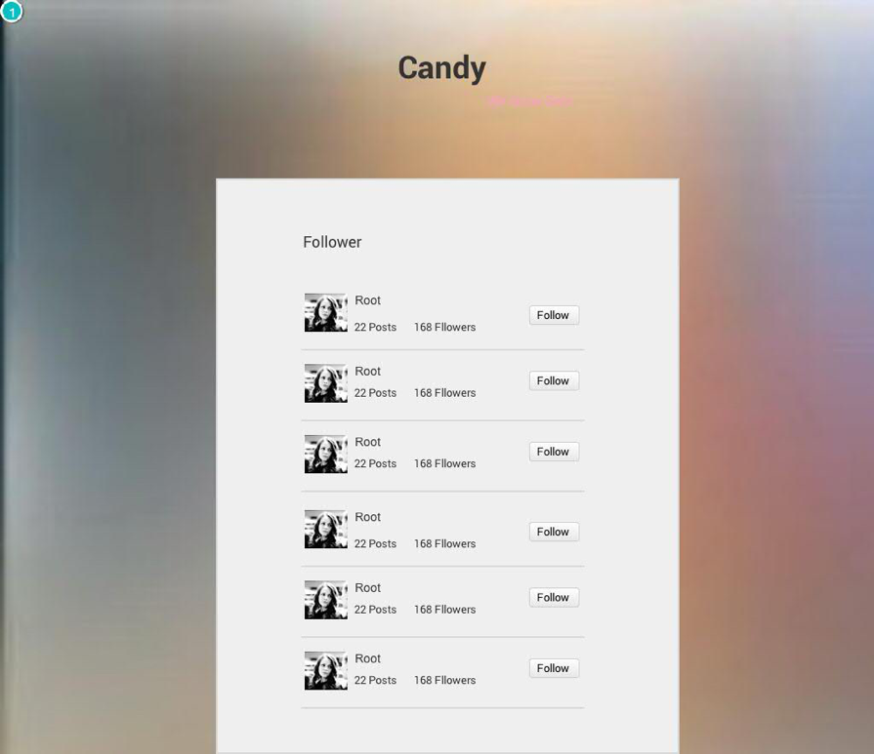

This page allows users to view his/her self’s follower and other user’s follower.